Ideation Phase
Define the Problem Statements

Date | 25 June 2026
Team ID
Project Name | A Comprehensive Measure of Well-Being
Maximum Marks | 2 Marks

Customer Problem Statement Template:

I am a Researcher, Policy Maker, Student, or Government Organization Representative trying to evaluate a country's human development level accurately and efficiently, but analyzing multiple socio-economic indicators manually is time-consuming and complex because life expectancy, education, and Gross National Income (GNI) per capita must all be considered together. This makes it difficult to quickly understand a country's development status and identify areas that require improvement.
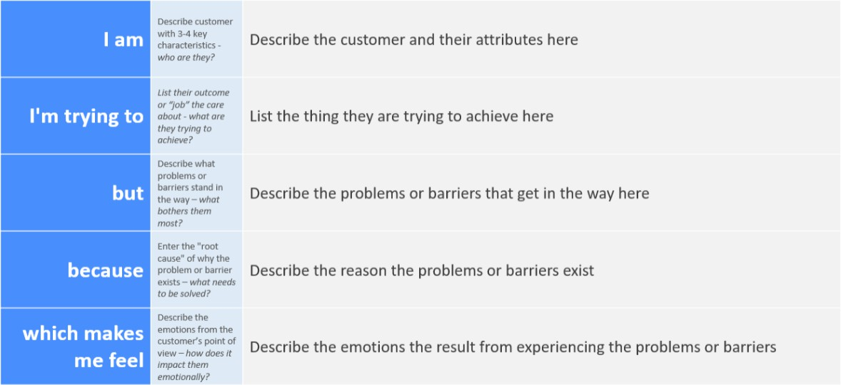

Example:

Problem Statement (PS) | I am (Customer) | I'm trying to | But | Because | Which makes me feel
PS-1 | A Researcher | Analyze the Human Development Index (HDI) of different countries | Calculating HDI manually is time-consuming and involves multiple socio-economic indicators | Health, education, and income data must be collected, cleaned, and analyzed before determining the HDI score | Delayed in conducting research and comparing countries effectively
PS-2 | A Policy Maker | Identify countries that require development improvements | It is difficult to quickly assess development levels using raw statistical data | Multiple indicators such as life expectancy, education, and GNI per capita must be evaluated together | Less confident in making informed policy decisions
PS-3 | A Student / Data Analyst | Learn how machine learning predicts HDI scores | Understanding relationships among development indicators is challenging | Large datasets require preprocessing, visualization, and predictive modeling | Confused about applying data science techniques to real-world problems
PS-4 | A Government Organization | Monitor and compare national development performance | Manual analysis of development indicators is slow and resource-intensive | Development reports require extensive statistical analysis and comparison | Concerned about delays in planning effective development programs

